**ASSIGNMENT 3**

Python

|  |  |
| --- | --- |
| Assignment Date | 19 September 2022 |
| Student Name | Divyasree R |
| Student Roll Number | 820419104021 |
| Maximum Marks | 2 Marks |

**1.Consider a list (list = []). You can perform the following commands: insert i e: Insert integer at position . print: Print the list. remove e: Delete the first occurrence of integer . append e: Insert integer at the end of the list. sort: Sort the list. pop: Pop the last element from the list. reverse: Reverse the list. Initialize your list and read in the value of followed by lines of commands where each command will be of the types listed above. Iterate through each command in order and perform the corresponding operation on your list.**

**PROGRAM:**

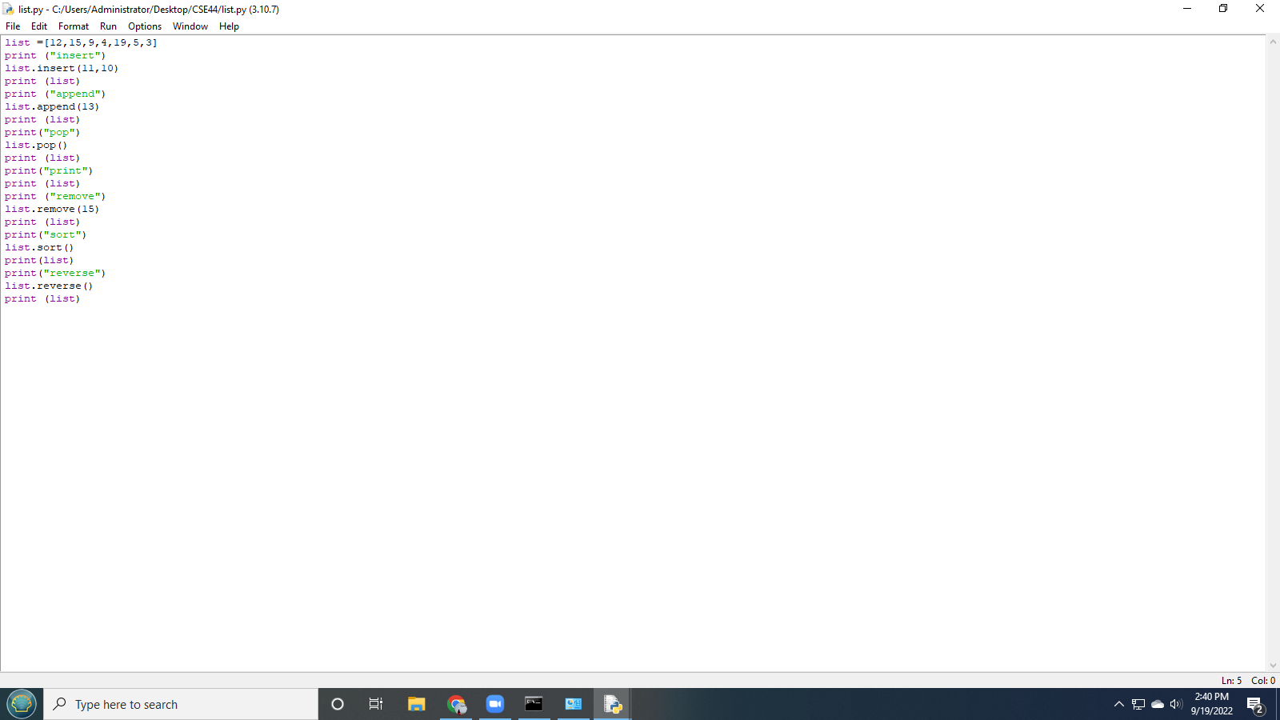

**OUTPUT SCREEN:**

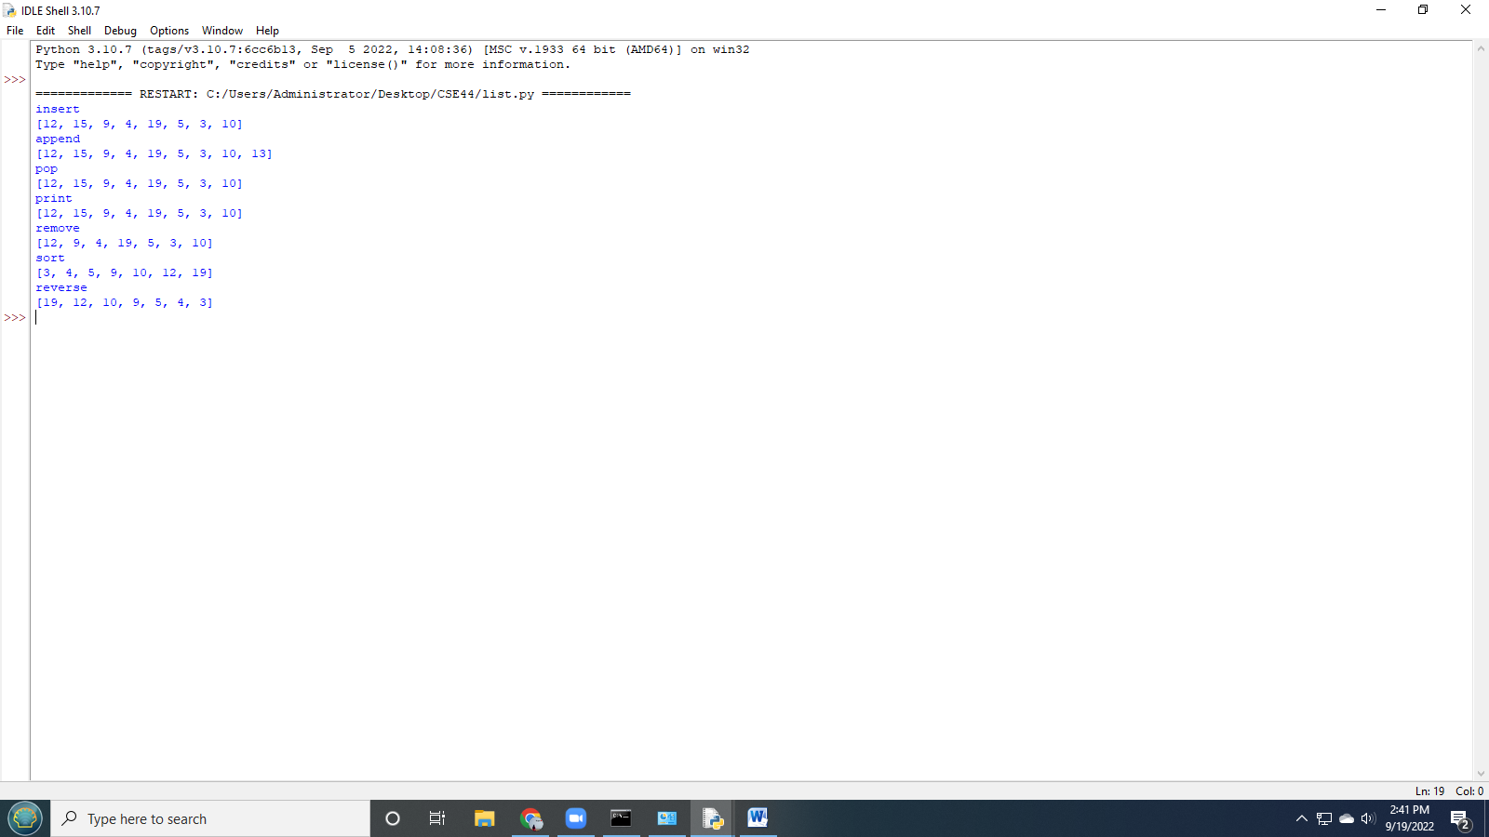

**2.Write a Calculator program in Python?**

**PROGRAM:**

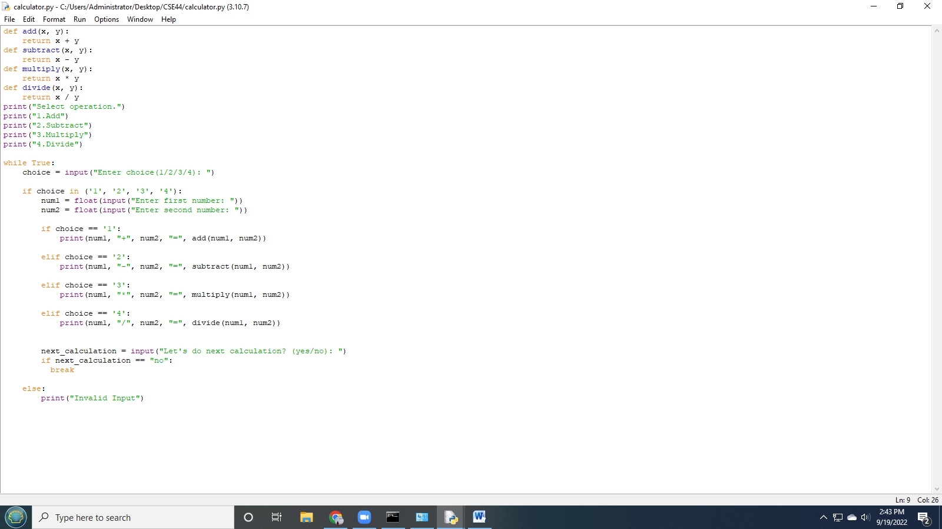

**OUTPUT SCREEN:**

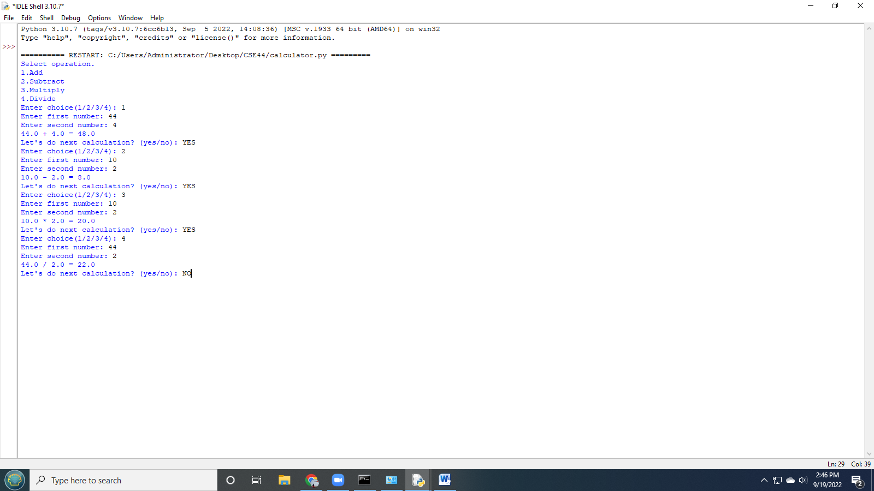

**3.Write a program to concatenate, reverse and slice a string?**

**PROGRAM:**

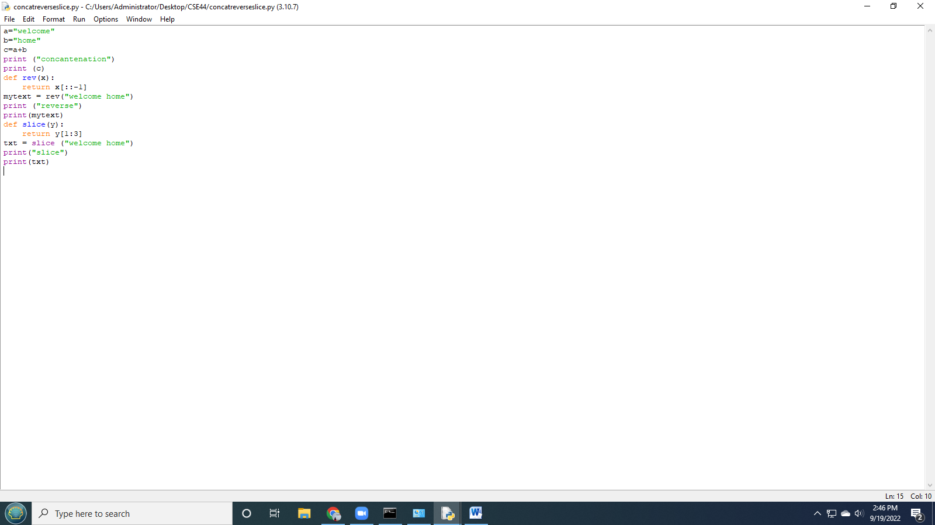

**OUTPUT SCREEN:**

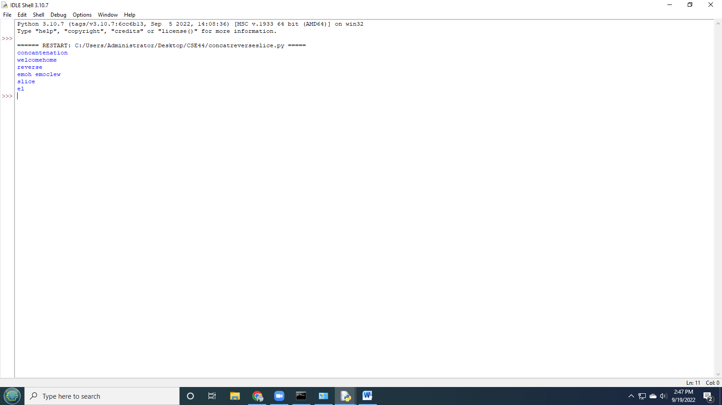

**4.Why is python a popular programming language?**

Even those who are unfamiliar with coding have likely heard of Python. What began as a hobby project named after a British surreal comedy troupe, Python has grown across three decades to become one of the world’s foremost coding languages. There’s no denying Python’s popularity. And, if current trends are any indication, it will likely remain in high demand for years to come. Here, we take a brief look at nine factors that have helped make Python one of the world’s leading programming languages.

1. It is easy to learn
2. It has an active, supportive community
3. It is flexible, efficient, fast and reliable
4. Python offers versatile web-development solutions
5. It is widely used with IOT technology

**5.What are the frameworks that can be used with python?**

In total, there are dozens and dozens of Python frameworks. But since you care about your time, here are 25 Python frameworks that stand out the most. Zope, CubicWeb ,AIOHTTP, Dash, Bottle, CherryPy, Falcon, Django, Flask, Growler, Pylons, Pyramid, Sanic, Hug, Morepath, Pycnic, Tornado, TurboGears, Web2py,FastAPI,Grok,BlueDream,Quixote,Weppy.

### 6.The full form of WSGI?

### The Web Server Gateway Interface (WSGI, pronounced whiskey or WIZ-ghee) is a simple calling convention for web servers to forward requests to web applications or frameworks written in the Python programming language. The current version of WSGI, version 1.0.